**Read me file**

Instructions:

1. start up the command line on your computer
2. enter cd into the command line and the location of the file e.g. cd C:\Users\Rory Horkan\surveyApp3
3. if you have ionic installed (if not follow this tutorial:<https://www.youtube.com/watch?v=Q2RCqjDO03w>) enter ionic serve which will launch the app on your browser
4. you will be greeted at the about page which will give you a guide on how to work the app

What is the App?

The app is a simple survey app that asks the user three questions: what is their name, what their favourite colour is and what is their favourite sports. They can click on the results page to see their results along with everybody else’s results.

Features used:

* Google Sheets API (for data storage)
* A text box for the user’s name
* A dropdown box for the selection of colours
* Tick/radio buttons for the sports sections.

Sources used:

Youtube Video showing a survey template tutorial: <https://www.youtube.com/watch?v=DJotOLNrM8M&t=456s>

Sheetsu A google sheets to api converter tool : <https://sheetsu.com/>

Tools:

- Ionic

- Notepad++

- Google Chrome

- Ionic Creator

- Google Sheets (for the data storage via api) Link to the google sheet: <https://drive.google.com/open?id=1-h01lKKdYUZ-t90fDzHFKTHgvJQPd1I2j75fsQq81DI>

Developers note: the storage of the data is done using a website called sheetsu (link here: <https://sheetsu.com/>) This is done by entering the google sheets url into the create api form on the site. Once the api link was created I added the link to the services.js file and entering the code as follows:

angular.module('app.services', [])

.service('Survey', ['$http', function($http){

var api_url = 'https://sheetsu.com/apis/v1.0/ce022984afc2';

var currentID = 1;

var ret = {

all: function(){

return $http.get(api_url).then(function(resp){

if (resp.data.length > 0) currentID = parseInt(resp.data[resp.data.length-1].id);

return resp.data;

});

},

add: function(data){

currentID++;

data.id = currentID;

return $http.post(api_url, data).then(function(resp){

return resp.data;

});

}

}

ret.all();

return ret;

}]);

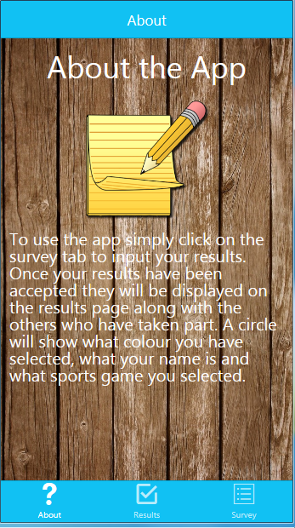

*Users will be greeted with the about page*

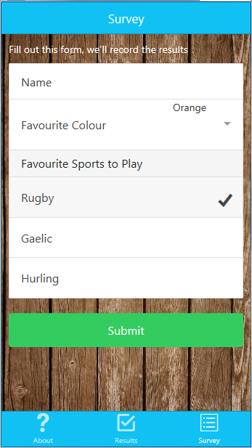

*The form that the user will use to implement their data*

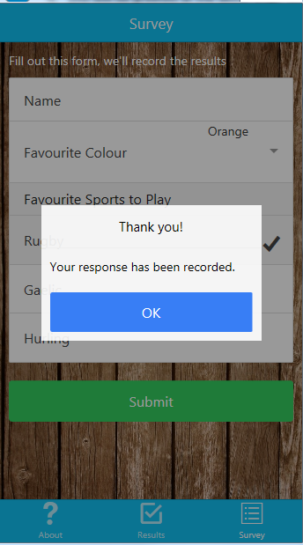

*Confirmation message when the data is entered*

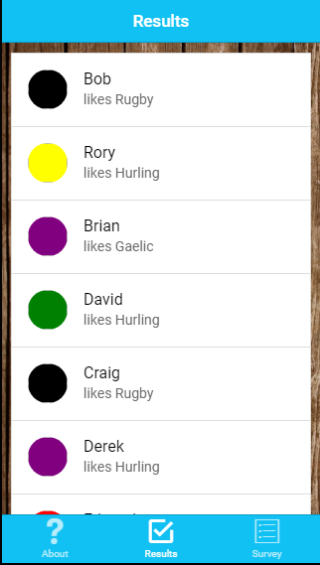

*Results of the survey shown with all those who participated*